Q.1. Write a Java program, to take a HDFS Path as input and display all the files and sub-directories in that HDFS path.

Ans.1

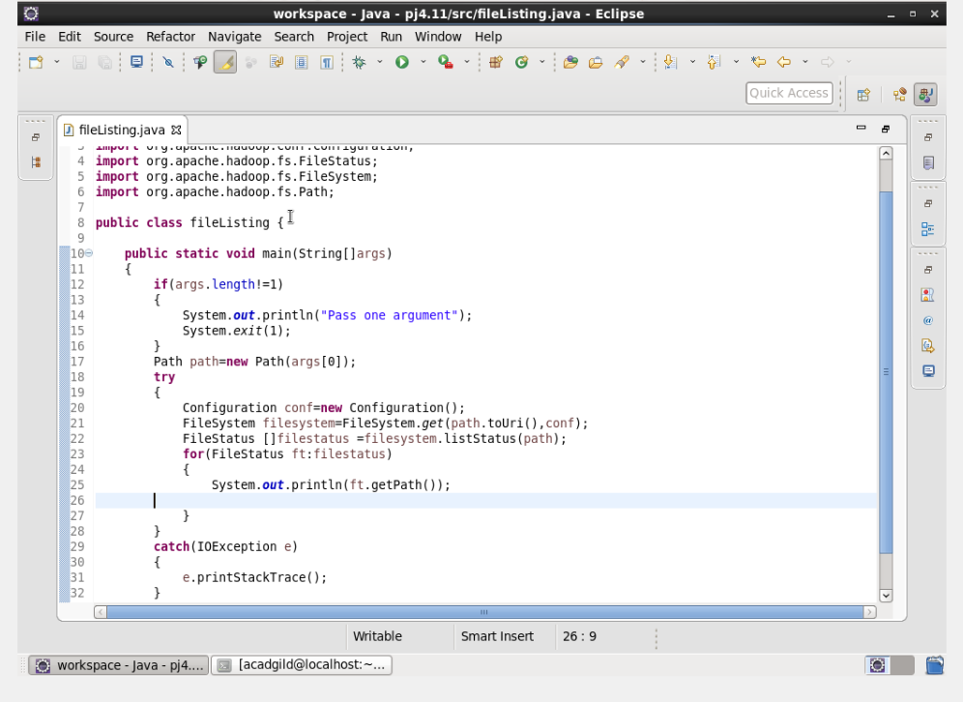

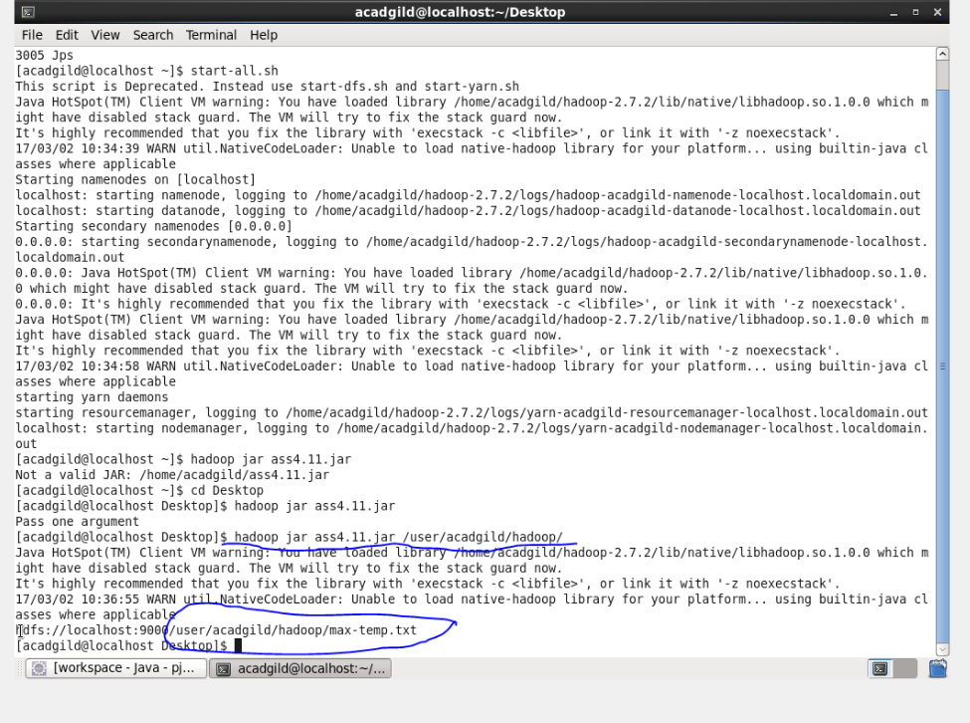

Q.2. Modify the previous program to list all the files and sub-directories in the HDFS path recursively.

Ans. 2.

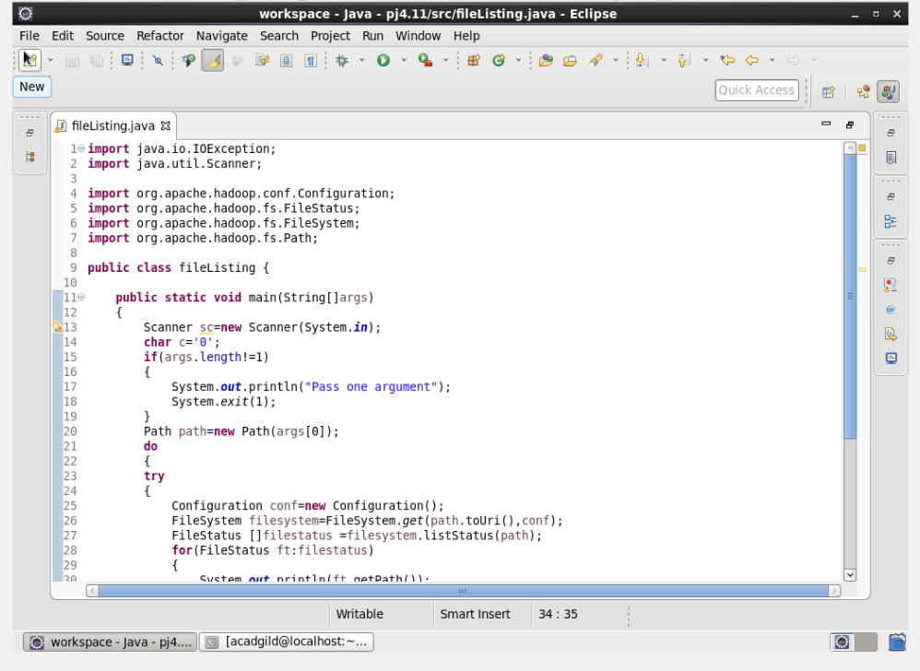

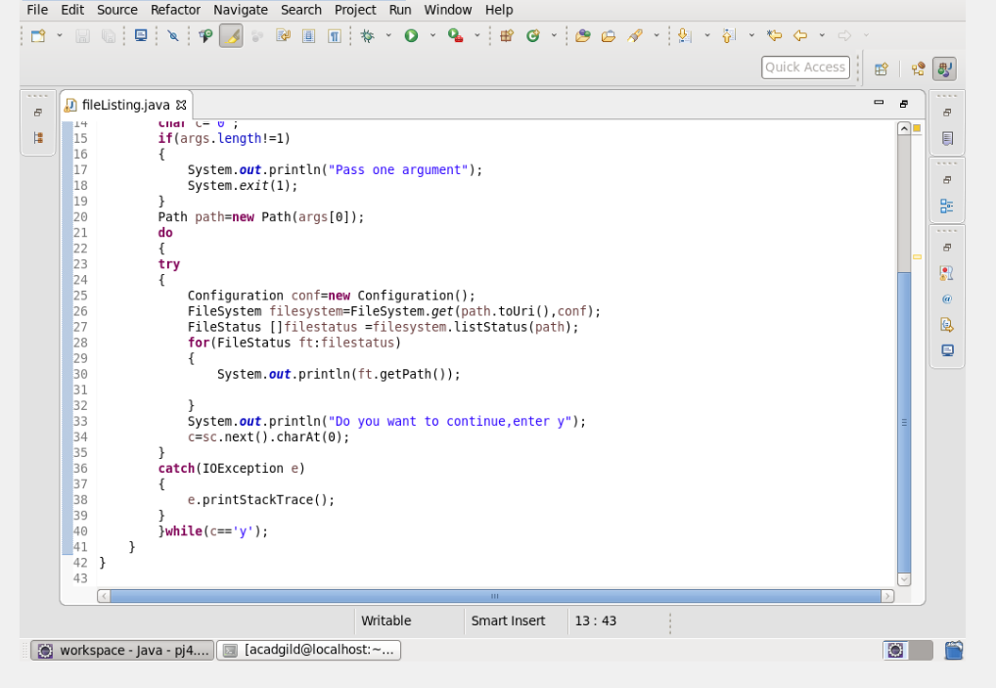

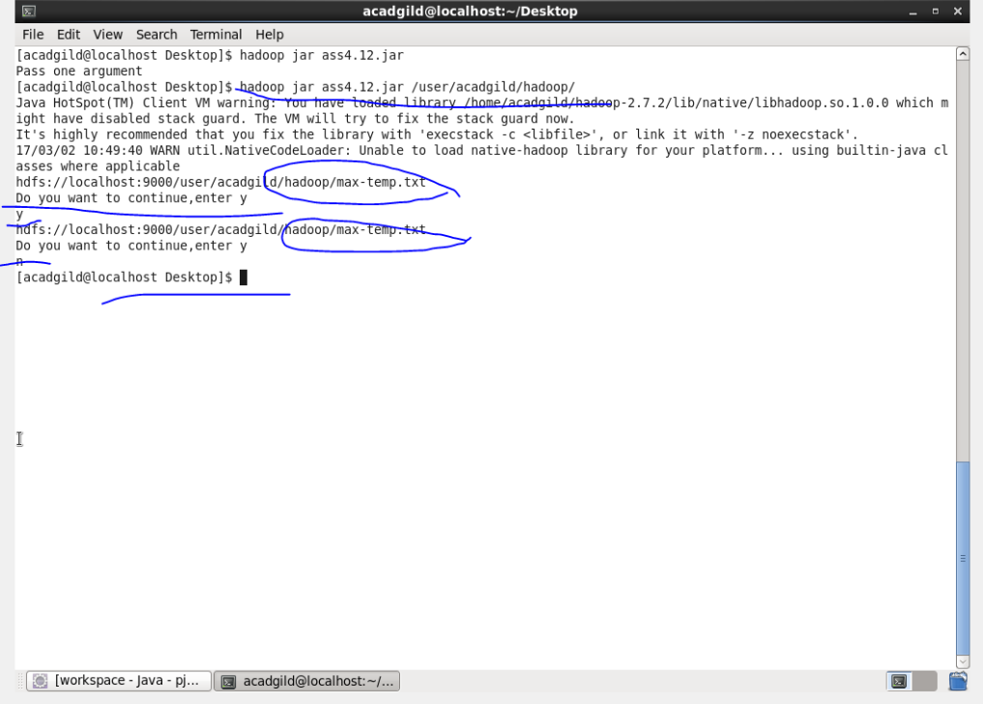

Q3. Modify the previous program to take multiple HDFS paths (separated by space) and list all the files and sub-directories in those HDFS paths recursively

Ans 3.

